CANDIDATE FOR ELECTION AS GRAND MASTER – 10 MARCH 2021

(Extract from nomination form submitted)

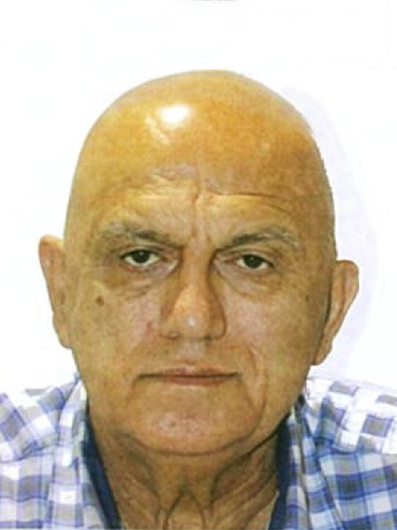

Antoine GEORGES

Past Deputy Grand Master

Lodge memberships: Lodge Punchbowl No 244; Lodge Kilwinning No 13; Lodge Hellenic Arcadia No 177; Grand Stewards’ Lodge No 1022;

The Cedars Lodge No 1041

Age: 66 Years Married

Awards/Titles (other than Masonic) N/A

Education/Professional Qualifications

Community Justice Mediator; Diploma in Social Welfare; Translator/Interpreter (NAATI)

Brethren

I present myself to you as a candidate for Grand Master of our great United Grand Lodge of NSW & ACT. I am the immediate Past Deputy Grand Master, having served that office for 3 years. I have served the ceremonial team from Grand Steward to Senior Grand Warden, with 2 years as the Grand Director of Ceremonies. I have dedicated myself to the masonic experience with great passion and vigour and have always given my utmost to the continued success of our Craft and the well­ being of the brethren.

This election is a time of great reflection on our past, our present and future direction as a fraternal organisation. We live in the age of Covid-19 which has decimated the world and tragically taken a great many lives. And yes, even our craft and the way we operate has been impacted.

We cannot however operate apart from the society in which we live and hope to continue to grow in this 21st Century. Like every organisation we must constantly review and reflect on our achievements and failures in all their aspects.

Every organisation, every corporate entity, every board, every chief executive must and should aspire to implement the highest levels of good corporate governance, operations, and communication. We must ensure our ritual continues to be of the highest standards. We must ensure charity remains our core goal. We must ensure that we operate as an organisation of the 21'¹ century and implement all that is necessary to overcome our shortcomings. We must ensure the continued growth of freemasonry towards the next 100 years.

To this end we must harness the knowledge and experience of every member of our fraternity. We must overcome any tribal mentalities and call upon all the members of our Grand Lodge to contribute through their wisdom, knowledge, and experience.
We must harness the energies of our newest and youngest members to ensure our knowledge and experience is passed on. We must ensure the next generation is equipped to take our fraternity forward. Our lodges must receive the support to operate efficiently and strive towards excellence, and our brethren the tools to derive satisfaction from their successes.

If I am elected to the position of Grand Master, no mason will be on a holiday. All members of talent, knowledge and experience will be asked to contribute, and my door will be open to all. My leadership will give confidence to the future, make our dreams possible, continue the work started by those who came before us, enable those who will come after us, while never forgetting the ancient duties, customs, and traditions of Freemasonry, which are our methodology and our guide.

To this end brethren, you must concern yourself with three important questions:
- Where have we been?
- Where are we now?
- And where are we headed as an organisation?
Look well to your ballot. Kind fraternal regards,
RW Bro Antoine Georges PDGM

