CANDIDATE FOR ELECTION AS GRAND MASTER – 10 MARCH 2021

(Extract from nomination form submitted)

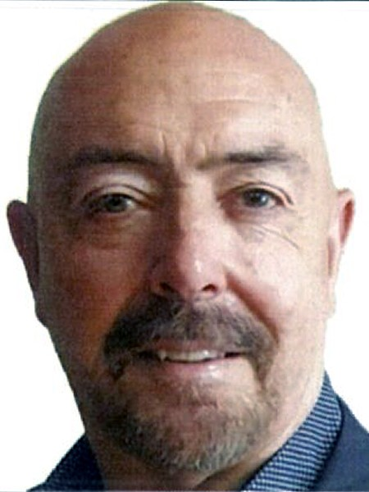

Lesley Norman HICKS

Past Assistant Grand Master, Past Regional Grand Counsellor Chairman Board of Management

Lodge memberships: Lodge Dawn No 511; Twin Towns Daylight No 436; Lodge Cavanbah No 231; Lodge Novacastria No 765

Age: 60 Years Married: Narelle

Awards/Titles (other than Masonic) Justice of the Peace Education/Professional Qualifications

Various Business, Training, Safety, Assessment and Management Certificates.
Company Director/CEO and business owner for 28 years.

Brethren: In nominating for the office of Grand Master I believe that I have much to offer in the way of experience, energy, and work ethic. It is the obligation of any new Grand Master to take what has been gifted to him by our Past Grandmasters and expand on the positives, to grow the Craft and to lead it into the future with focus and passion. A Grand Master must be a positive influence, he should always listen, learn, and act for the betterment of the Craft and, he must be a decision maker.
I am fortunate, in my life, to have 3 great loves. My Family, my Freemasonry, and my Martial Art, have all had a great and positive influence on me. I have been married to Narelle for 40 years, and we have 2 wonderful children and 7 fantastic Grandchildren who provide me with the support and stability needed to undertake the great responsibilities associated with this especially important and honourable leadership role. From a work perspective, I began my journey in Martial arts in 1979 and turned my life's passion into my business, such that I have now grown my organisation into a NSW and interstate body with over 10,000 members. This was achieved by using sound leadership skills within the business environment and by developing a sound product, promoting it with integrity, embracing technology and by constantly working hard on growth and retention. Being acutely aware of the difficulties associated with growing a membership-based organisation, I understand that transparency, communication, education, and promotion must be at the forefront of all decision making to ensure the Craft's continued growth and success in an ever-changing & sometimes challenging environment.
For our Craft to grow, we must maintain and enhance quality meeting places, encourage good ceremony, deliver transparent governance, and have a steady stream of confident, well-adjusted men joining our organisation, and we need to offer these new members the support, education, and guidance that they crave. Moving forward, better communication streams and enhanced technology will p!ay an important role in our future and, if COVID-19 has taught us anything, it is that technology can be our friend. We need to take the lessons learned over recent months and use them to our advantage, and while we are modernising, we must ensure that this is not done at the expense of our wonderful traditions. There is no doubt that the evolving revisions to our Membership data-base management system, and other continued advancements, will provide our Lodge Secretaries, office holders and brethren with a most modern management system. With this solid platform and by working with the immense talent that we have within our jurisdiction; we will place our Craft at the forefront of our local communities, raise our profile, improve membership, and aid those in need.
Like my father, I joined Freemasonry because I understand and believe in the values of its teachings. have served our craft constantly for many years and I have learned plenty. I served as DGIW in District 11, RGC Region 1 for 2 terms, Chairman of Operations, and I now serve as Chairman of the Board of Management. I believe that this consistent and progressive experience now sees me well placed for this important leadership role. I have spent the best part of my life successfully promoting and growing a membership-based organisation and I can promise you that the strong work ethic I have become known for will continue. My clear message is that 'you are what you do, NOT what you say you will do'. If given the honour of being your Grand Master I will continue to bring leadership and integrity to that office as those before me have, I will work hard with communication, growth, and membership retention at the forefront of all decisions and, most importantly, I will always listen.
Brethren: this election is not about me; it is about us. NSW and ACT Freemasonry is now back in action and this was not achieved by accident, we have all worked hard during the pandemic and learned plenty. We need to keep prospering and use the knowledge acquired during the COVID-19 situation as a springboard to our future. We must now take advantage of every opportunity, and I am excited about the prospect of leading our beloved Craft toward an exciting, strong, and stable future.
Our future is in your hands. I have much to offer our Craft, and I humbly submit my nomination.

