CANDIDATE FOR ELECTION AS GRAND MASTER – 10 MARCH 2021

(Extract from nomination form submitted)
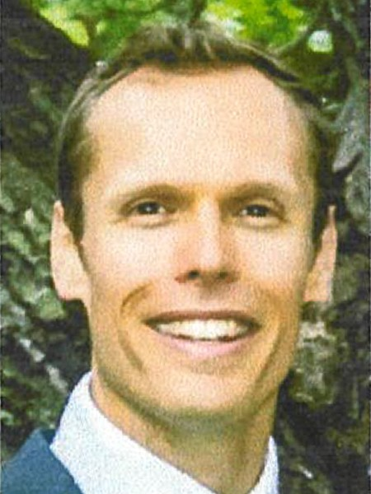

Owen John PARRY

Past Junior Grand Warden, Deputy Grand Superintendent of Works

Lodge memberships: Lodge Trinitarian No 978; Grand Stewards’ Lodge No 1022

Age: 42 Years Married

Awards/Titles (other than Masonic) Justice of the Peace Education/Professional Qualifications

Master of Environmental Engineering Management, Graduate Certificate of Sustainable Agriculture, Bachelor of Civil and Environmental Engineering, Advanced Diploma of Leadership and Management, Diploma in Engineering Practice, Certificate II in Animal Studies, PRINCE2 Foundation and Practitioner in Project Management

Brethren, I have the motivation, qualifications and experience to support my nomination for Grand Master. The combination of my Masonic, community and professional experience, has given me a unique understanding and set of skills to successfully manage the demands of the role.

I am active in my Lodges and have served in the Grand Ceremonial Team for many years, ultimately performing the Junior Grand Warden role. I am currently the Deputy Grand Superintendent of Works, and provide advice on Masonic buildings based on my professional experience and qualifications. I have developed a strong appreciation for the ceremonial and
the administration of our organisation, both key areas for an applicant for Grand Master to fully understand.

I am a qualified civil engineer (Master of Environmental Engineering Mgt, Graduate Certificate of Sustainable Agriculture, Bachelor of Civil & Environmental Engineering, Advanced Diploma of Leadership and Mgt). As a Senior Manager, I currently am and have managed many diverse, high profile infrastructure projects, worth many millions of dollars. These projects have necessitated me engaging in complex negotiations with politicians, government agencies, private industry and the general public. I have sat on Executive Steering Committees making determinations for major public works and applied good governance and transparency in all transactions. My valuable experience managing people, budgets, competing priorities and complex issues will benefit the Craft.
I played rugby for Drummoyne and was on the Executive Committee. I won the Presidents Player of the Year award and was voted the Players Player. For the Engineering Heritage Committee, Institution of Engineers, I was a committee member and Honorary Secretary. My wife and sons, the beach and my garden encompass the rest of my loves.
I am consultative by nature, so I want to hear and understand what is important to you. Listening to you will also help to gain and retain Brethren in our wonderful Craft. You will have a voice irrespective of your location or rank. You have valuable knowledge, enthusiasm and experience, and I want to make the most of it. Under my direction, the Grand Lodge will provide you the support necessary to make a worthy idea a reality. This will help to engage and motivate us all, by allowing everyone to become an important part of the organisation.
Together we can create a more accessible, successful and appealing organisation with professional administration and modern infrastructure, for prospective and existing members. I am committed to improving our Masonic experience, as well as the longevity of our organisation. I will represent you, present a welcoming face to the public, and uphold the tenets of the Craft, and I respectfully ask for your vote.

RW Brother Owen Parry

